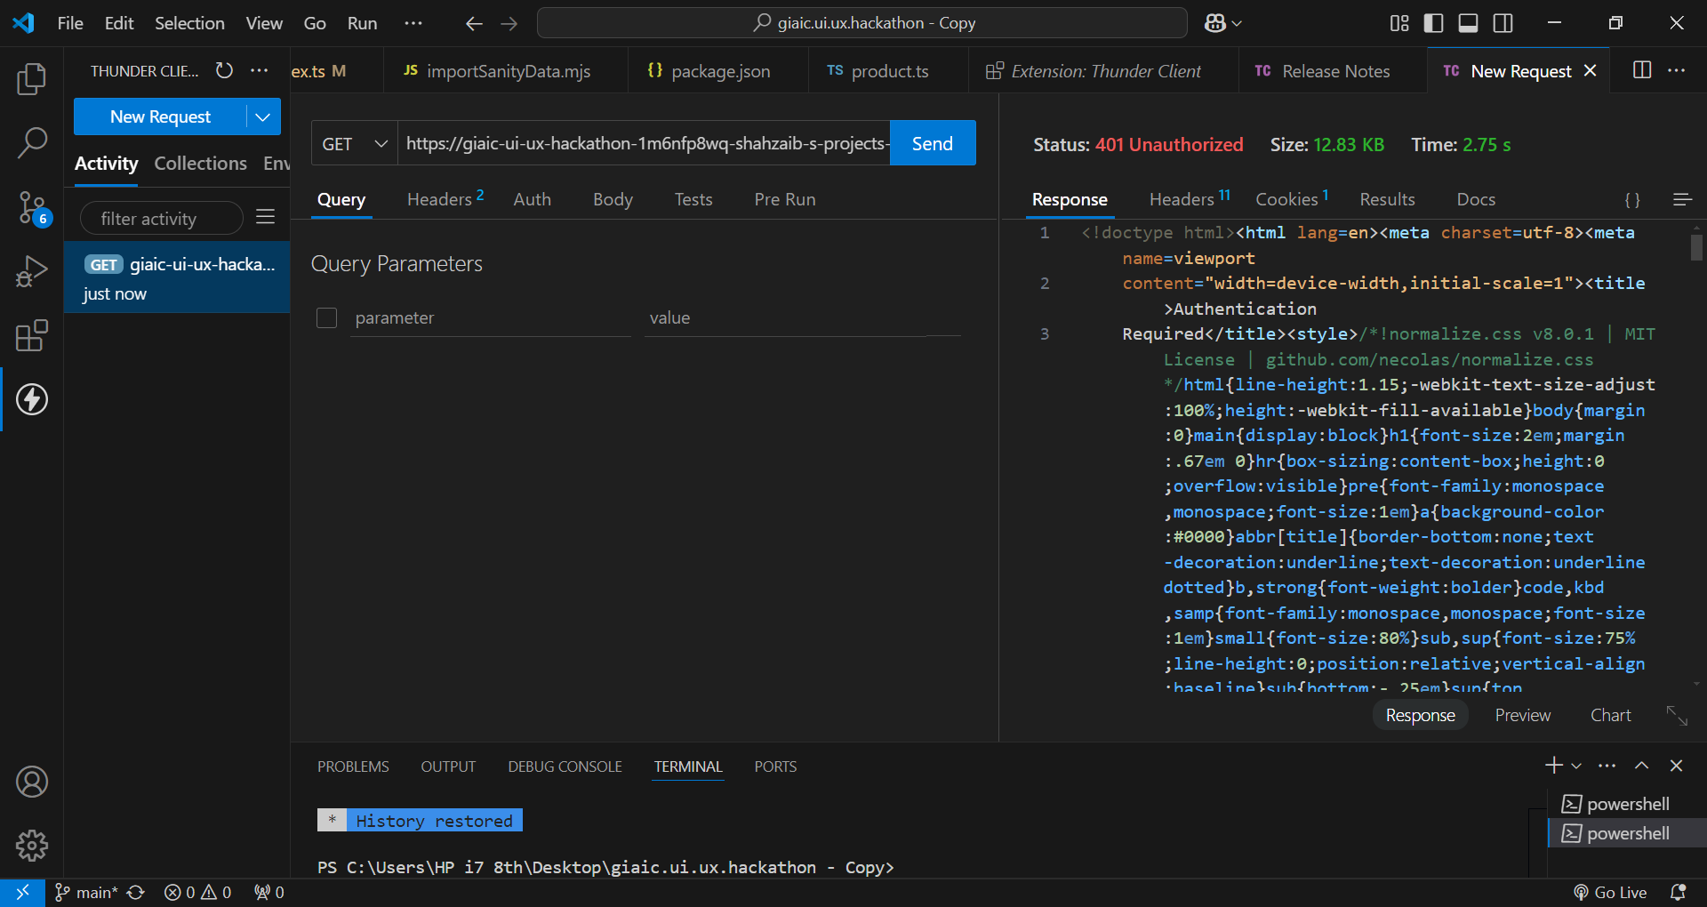

|  |  |  |  |  |  |  |
| --- | --- | --- | --- | --- | --- | --- |
| Test Case ID | Description | Steps | Expected Result | Actual Result | Status | Remarks |
| TC001 | Validate product listing | Open product page > Verify products | Products displayed | Products  displayed | Passed | No issues found |
| TC002 | Test API error handling | Disconnect API > Refresh page | Show fallback message | Fallback message shown | Passed | Handled gracefully |
| TC003 | Check cart functionality | Add item to cart > Verify cart | Cart updates correctly | Cart updates correctly | Passed | Works expected |
| TC004 | Test responsiveness layout | Resize browser window > Check layout | Layout adjusts properly | Layout adjusts properly | Passed | Responsive verified |

npm install –g lighthouse

lighthouse <http://localhost:3000> --view